Name: Mansij Ranjit

Roll no: 22

**Database Assignment 2**

Question 1: [Japanese Cities' Names](https://www.hackerrank.com/challenges/japanese-cities-name/problem)

*SQL Script Solution*:

SELECT DISTINCT NAME FROM CITY WHERE COUNTRYCODE LIKE 'JPN';

Screenshot:

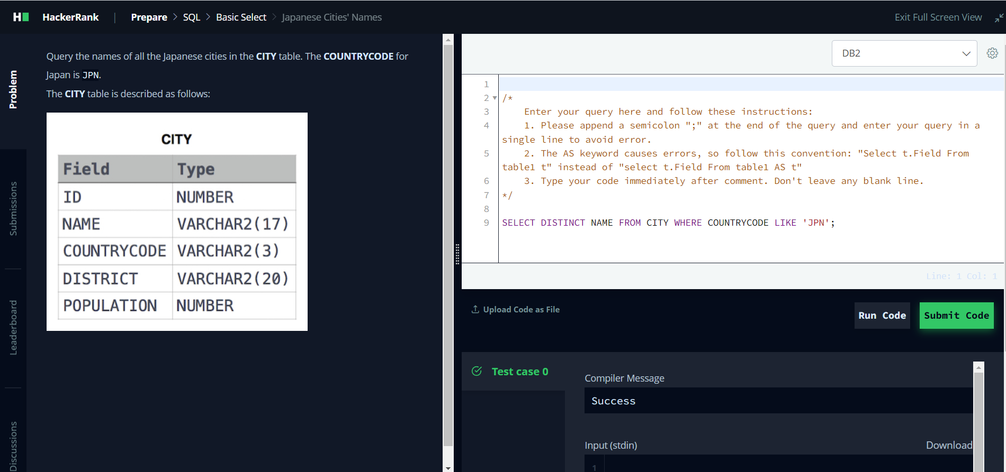

Question 2: [Weather Observation Station 3](https://www.hackerrank.com/challenges/weather-observation-station-3/problem?isFullScreen=true)

*SQL Script Solution*:

SELECT DISTINCT CITY FROM STATION WHERE ID IN (SELECT ID FROM STATION WHERE MOD(ID,2)=0);

Screenshot:

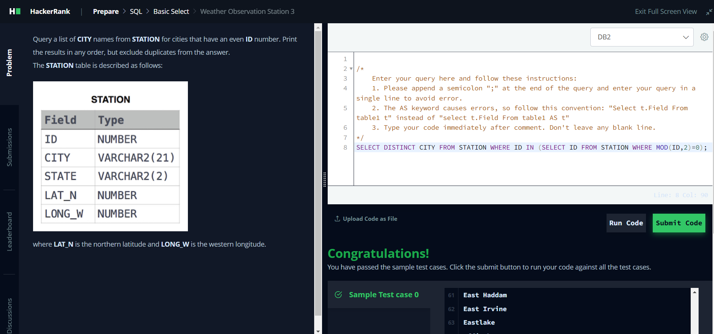

Question 3: [Weather Observation Station 5](https://www.hackerrank.com/challenges/weather-observation-station-5/problem)

*SQL Script Solution*:

SELECT CITY,LENGTH(CITY) FROM STATION ORDER BY LENGTH(CITY) ASC,CITY LIMIT 1;

SELECT CITY,LENGTH(CITY) FROM STATION ORDER BY LENGTH(CITY) DESC,CITY LIMIT 1;

Screenshot:

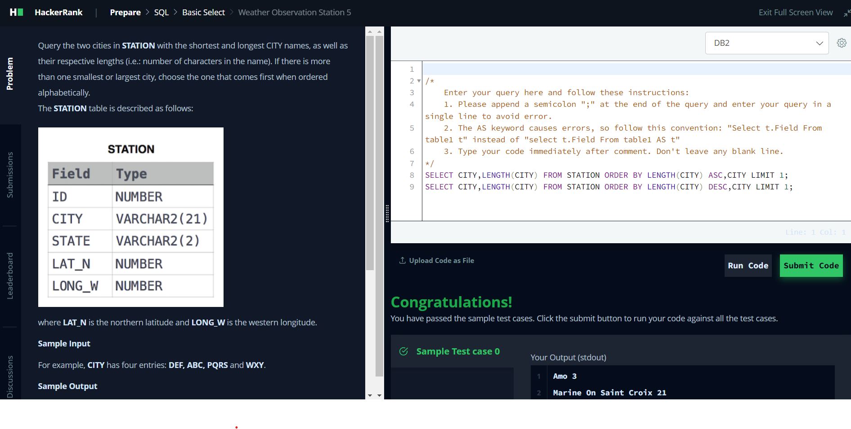

Question 4: [The Blunder](https://www.hackerrank.com/challenges/the-blunder/problem?isFullScreen=true)

*SQL Script Solution*:

SELECT CEIL(AVG(SALARY - REPLACE(SALARY,0,''))) FROM EMPLOYEES;

Screenshot:

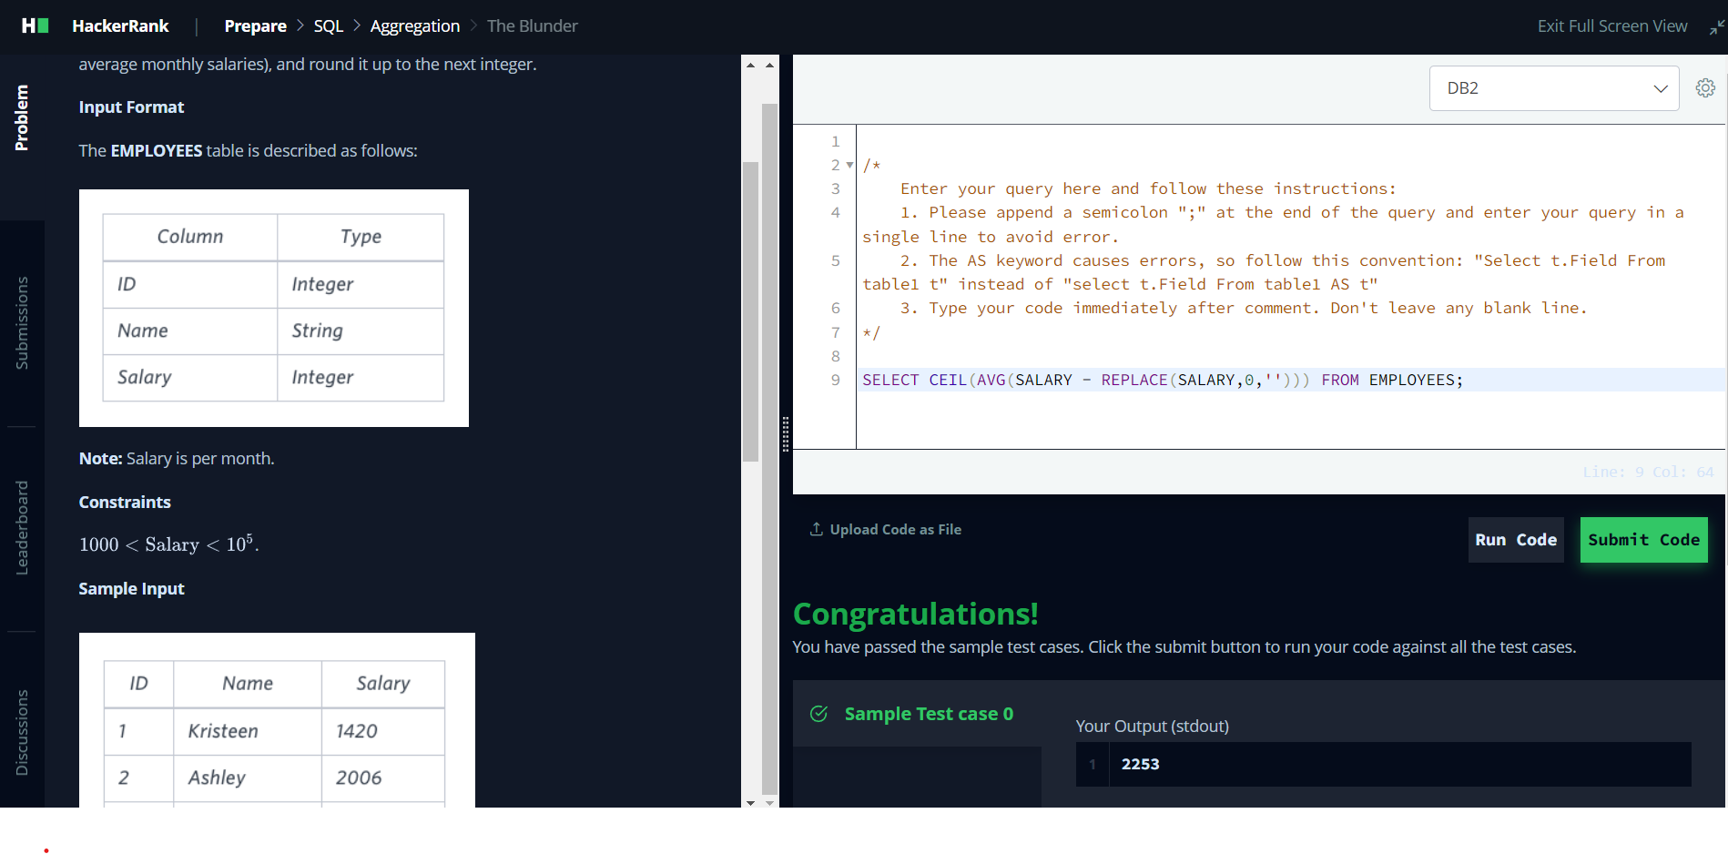

Question 5: [Weather Observation Station 18](https://www.hackerrank.com/challenges/weather-observation-station-18/problem)

*SQL Script Solution*:

SELECT CAST(ABS(MAX(LAT_N)-MIN(LAT_N))+ ABS(MAX(LONG_W)-MIN(LONG_W)) AS DECIMAL(10,4)) FROM STATION;

Screenshot:

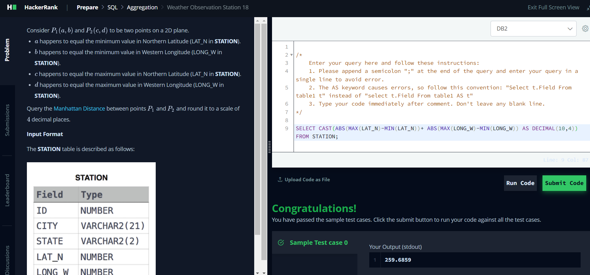

Question 6: [Average Population of Each Continent](https://www.hackerrank.com/challenges/average-population-of-each-continent/problem?isFullScreen=true)

*SQL Script Solution*:

SELECT COUNTRY.CONTINENT,FLOOR(AVG(CITY.POPULATION)) FROM COUNTRY JOIN CITY ON CITY.COUNTRYCODE=COUNTRY.CODE GROUP BY COUNTRY.CONTINENT;

Screenshot:

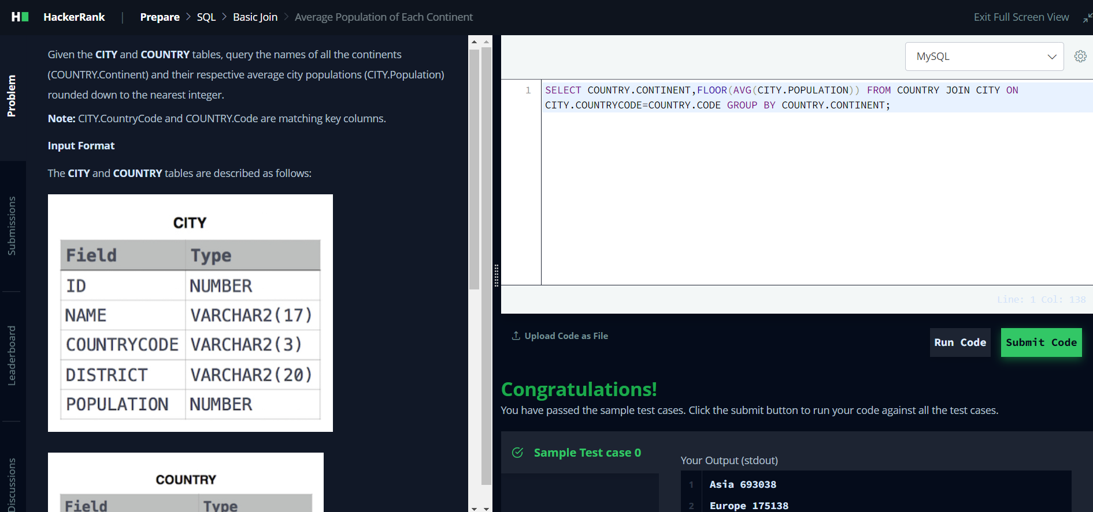

Question 7: [The PADS](https://www.hackerrank.com/challenges/the-pads/problem)

*SQL Script Solution*:

SELECT NAME || '(' || SUBSTR(OCCUPATION,1,1) || ')' AS NAME FROM OCCUPATIONS ORDER BY NAME;

SELECT 'There are a total of ' || COUNT(OCCUPATION) ||' ' || LOWER(OCCUPATION) ||'s.' FROM OCCUPATIONS GROUP BY OCCUPATION ORDER BY COUNT(OCCUPATION), OCCUPATION ASC;

Screenshot:

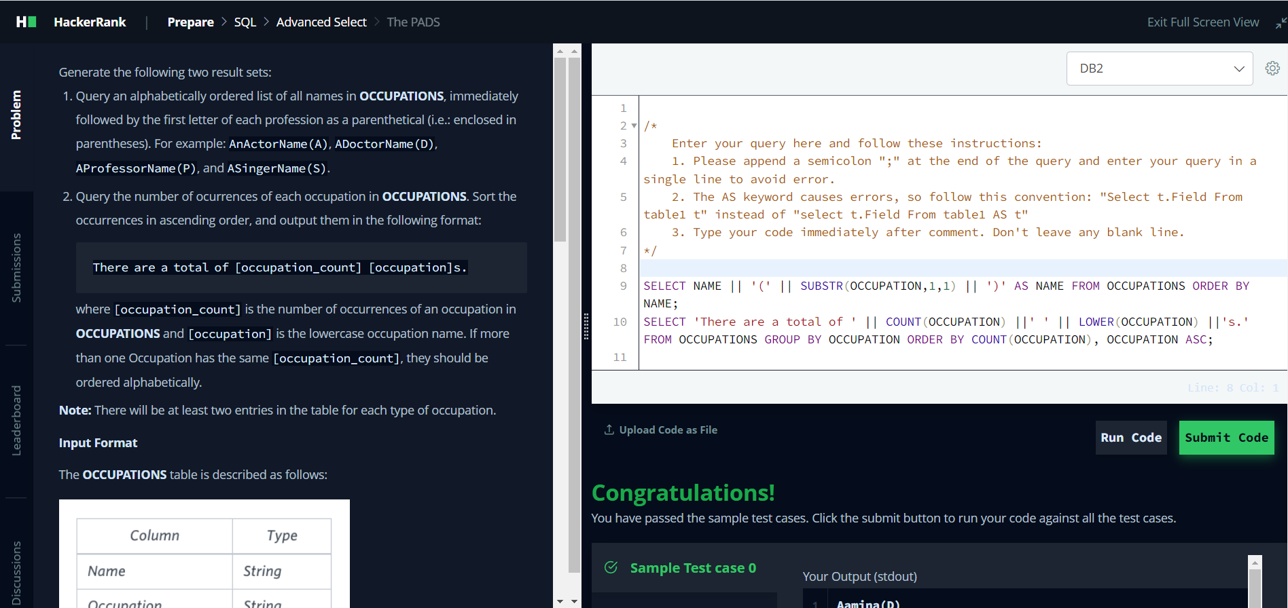

Question 8: [Type of Triangle](https://www.hackerrank.com/challenges/what-type-of-triangle/problem) (Use Case statement)

*SQL Script Solution*:

SELECT CASE

WHEN A+B<=C OR B+C<=A OR A+C<=B THEN 'Not A Triangle'

WHEN A<>B AND B<>C AND C<>A THEN 'Scalene'

WHEN A=B AND B=C THEN 'Equilateral'

WHEN A=B OR B=C OR C=A THEN 'Isosceles'

END

FROM TRIANGLES;

Screenshot:

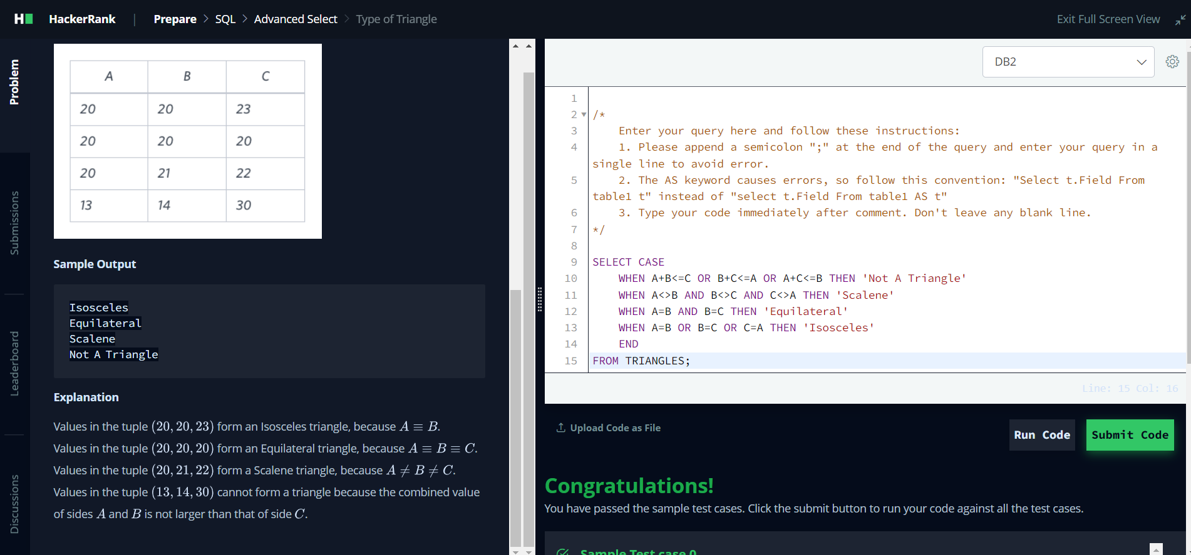

Question 9: [Weather Observation Station 13](https://www.hackerrank.com/challenges/weather-observation-station-13/problem)

*SQL Script Solution*:

SELECT CAST(SUM(LAT_N) AS DECIMAL(10,4)) FROM STATION WHERE LAT_N>38.7880 AND LAT_N<137.2345;

Screenshot:

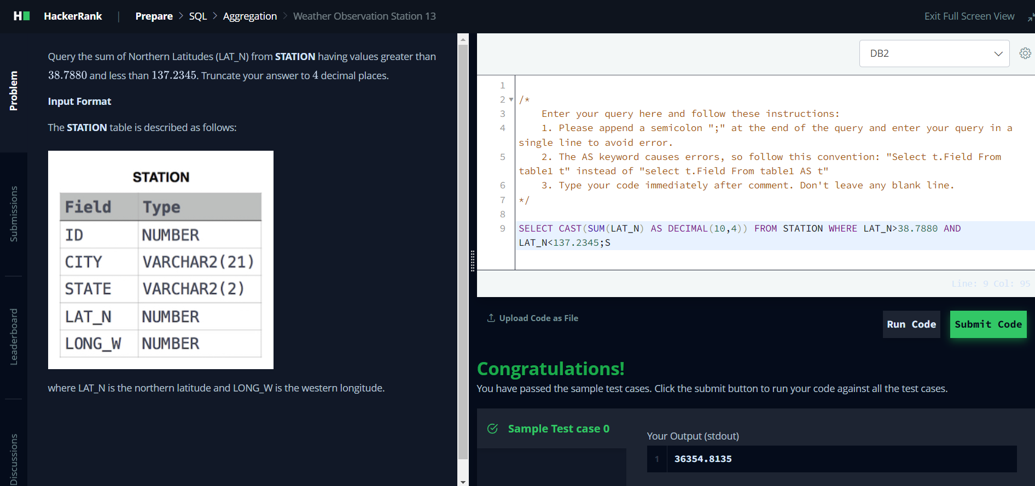

Question 10: [The Report](https://www.hackerrank.com/challenges/the-report/problem)

*SQL Script Solution*:

SELECT S.NAME, G.GRADE, S.MARKS FROM STUDENTS S INNER JOIN GRADES G ON G.GRADE>=8 AND S.MARKS BETWEEN G.MIN_MARK AND G.MAX_MARK ORDER BY G.GRADE DESC,S.NAME;

SELECT 'NULL',G.GRADE,S.MARKS FROM STUDENTS S INNER JOIN GRADES G ON G.GRADE<8 AND S.MARKS BETWEEN G.MIN_MARK AND G.MAX_MARK ORDER BY G.GRADE DESC,S.MARKS;

Screenshot:

